NAME:………………………………………………………………………………………………SIGNATURE:…………………….

LIN ………………………………………………………………………………………………………………

***DIVINE SECONDARY SCHOOL KITALA***

***UGANDA CERTIFICATE OF LOWER SECONDARY EDUCATION***

***MID-TERM 11 EXAMS 2024***

***CHEMISTRY PAPER 1 1HR:40MIN***

***Instructions***

AnswerallquestionsinsectionAandany oneinsectionB

Allyouranswersshouldbeclearinaneathandwritingtoavoidlossof marks. Answers in section A should be properly written in the spaces provided

Alldrawingsincludedshouldbeinpencil

Payattentiontothenumberofmarksavailableforeachquestion

Forexaminersuseonly

***SECTIONA***

|  |  |  |  |  |  |  |
| --- | --- | --- | --- | --- | --- | --- |
| Question | 1 | 2 | 3 | 4 | 5 | Total |
| Marksscored |  |  |  |  |  |  |

***SECTIONB***

|  |  |  |  |  |  |  |
| --- | --- | --- | --- | --- | --- | --- |
| Question | 6 | 7 |  |  |  | total |
| Marksscored |  |  |  |  |  |  |

***SECTIONA***

1. In an investigation to find out the changes whichoccur to substances under different conditions; Mr. MayanjaanS.3chemistryteacherillustratedthesechangesusingtheexamplesinthepicturesbelow;

|  |  |
| --- | --- |
| ChangetypeA | ChangetypeB |
|  |  |

Onadditiontotheaboveillustration;afterclassinvolvement,theyfoundoutthatotherchangesof type B also exist and are commonly done in everyday life among which were the following

|  |  |
| --- | --- |
|  |  |
| Process x | Process y |

* 1. IdentifythechangetypeAandBhappeningtomatter (2marks)

…………………………………………………………………………………………………………………………………………………………

…………………………………………………………………………………………………………………………………………………………

* 1. Statefourdifferencesbetweenthetypesofchangesyouhaveidentifiesin(a) (4marks)

…………………………………………………………………………………………………………………………………………………………

…………………………………………………………………………………………………………………………………………………………

…………………………………………………………………………………………………………………………………………………………

…………………………………………………………………………………………………………………………………………………………

…………………………………………………………………………………………………………………………………………………………

…………………………………………………………………………………………………………………………………………………………

* 1. Identifytheprocessesoccurringtomatterinprocesses (2marks)
     1. X:……………………………………………………………………………………………………………………
     2. Y:……………………………………………………………………………………………………………………
  2. MentionotherexamplesindailylifewherechangesoftypeAandBoccurapartfromtheones identified above (2 marks)

…………………………………………………………………………………………………………………………………………………………

…………………………………………………………………………………………………………………………………………………………

1. Your young brother bought ice from the shop, on reaching home, mum sent him to the Centre to buy sugar and he forgot his ice on the veranda, whichis directlyheated bythe sun. On returning,he found outthatalltheicehadturnedtoliquidandflowed,aftersometimehenoticedthattheverandahedid not mop was dry and he wondered how it came about.

Brieflyexplaintohimwhatcausedthechangeshesawusingyourknowledgeofthekinetictheoryof matter (6 marks)

………………………………………………………………………………………………………………………………………………………………

………………………………………………………………………………………………………………………………………………………………

………………………………………………………………………………………………………………………………………………………………

………………………………………………………………………………………………………………………………………………………………

………………………………………………………………………………………………………………………………………………………………

………………………………………………………………………………………………………………………………………………………………

………………………………………………………………………………………………………………………………………………………………

……………………………………………………………………………………………………………………………………………………………..

1. Belowisaheatingcurveforapuresubstance.Itshowshowthetemperaturerisesovertime,whenthe substance is heated until it melts, then boils.

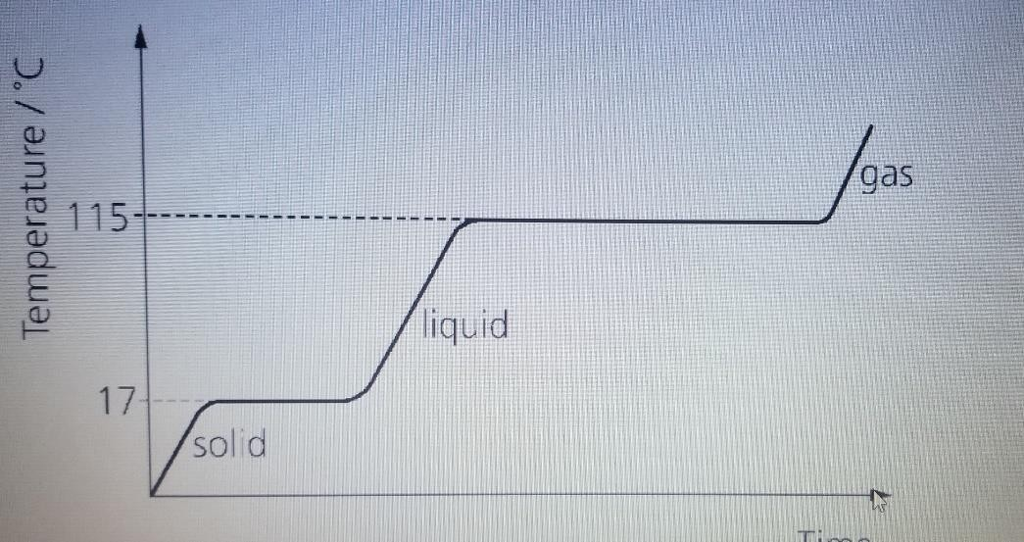

1

* 1. Whatisthe meltingpoint ofthesubstance? (

2

mark)

…………………………………………………………………………………………………………………………………

* 1. Whathappenstothetemperaturewhilethesubstancechangesstate? (1mark)

…………………………………………………………………………………………………………………………………………………………

…………………………………………………………………………………………………………………………………………………………

* 1. Thegraphshowsthatthesubstancetakeslongertoboilthantomelt.Suggestareasonforthis. (2 marks)

…………………………………………………………………………………………………………………………………………………………

…………………………………………………………………………………………………………………………………………………………

1

* 1. Howcanyoutellthatthesubstanceisnotwater? (

2

𝑚𝑎𝑟𝑘)

…………………………………………………………………………………………………………………………………………………………

…………………………………………………………………………………………………………………………………………………………

* 1. Sketcharoughheatingcurveforpurewater (1mark)

1. Incaseofafireoutbreakintheschoollaboratory,afireextinguishercanbeusedtostopthefire.
   1. Brieflydescribethestepsthatcanbefollowedwhenusingafireextinguisherwhen stoppingfire. (4 marks)

…………………………………………………………………………………………………………………………………………………………

…………………………………………………………………………………………………………………………………………………………

…………………………………………………………………………………………………………………………………………………………

…………………………………………………………………………………………………………………………………………………………

…………………………………………………………………………………………………………………………………………………………

…………………………………………………………………………………………………………………………………………………………

* 1. Identifythreeincidencesthatmaycausefireintheschoollaboratory (3marks)

…………………………………………………………………………………………………………………………………………………………

…………………………………………………………………………………………………………………………………………………………

…………………………………………………………………………………………………………………………………………………………

1. Chemistry is of great importance in many fields such as pharmaceuticals, agriculture, education, mineralextractionandmanyothers.Inasinglewrite-up,describethecontributionofchemistryinthe named fields. (7 marks)

………………………………………………………………………………………………………………………………………………………………

………………………………………………………………………………………………………………………………………………………………

………………………………………………………………………………………………………………………………………………………………

………………………………………………………………………………………………………………………………………………………………

………………………………………………………………………………………………………………………………………………………………

………………………………………………………………………………………………………………………………………………………………

………………………………………………………………………………………………………………………………………………………………

………………………………………………………………………………………………………………………………………………………………

………………………………………………………………………………………………………………………………………………………………

……………………………………………………………………………………………………………………………………………………………….

***SectionB.***

***Attemptanyonequestion(15 marks)***

1. Youareachemistworkinginaresearchlabstudyingthebehaviorofwater.Youhaveasampleof water at 25oC and want to investigate its changes of state under different conditions.
   1. At25oC,explainthestateofmatterofthewatersampleandtheintermolecularforcesinvolved.
   2. Ifyouincreasethetemperatureofthewatersampleto1000Cwhilemaintaining constantpressure, describe the changes of state that occur.
   3. Now,ifyoudecreasethetemperatureofthewatersampleto -100Cwhilemaintainconstant pressure, explain the changes of state that occur.
   4. Sketchtheheatingcurveforthechanges ofstatedescribedinparts(b)and(c),andlabelthe different regions of the curve with the corresponding state(s) of matter.
   5. Basedonthedatacollected,discusstheeffectoftemperatureandpressureonthechangesof states of water, and relate it to the kinetic theory of matter.
2. Youareachemistryteacherconductingalaboratory sessiontodemonstratethesafeandeffectiveuse of the Bunsen burner a heating apparatus.
   1. ExplainthestructureandworkingprincipleoftheBunsenburner.Includethedifferentparts ofthe burner and how it regulates the flow of the gas and air to archive different types of flames.
   2. OutlinethesafetyprecautionsandguidelinesthatstudentsshouldfollowwhenusingtheBunsen burner, including lighting and extinguishing the flame.
   3. DescribethedifferenttypeofflamesproducedbytheBunsenburnerandexplaintheappropriate applications for each type of flame in the laboratory work.